# Unlimited Well – System Use Cases

## UC1. Order goods

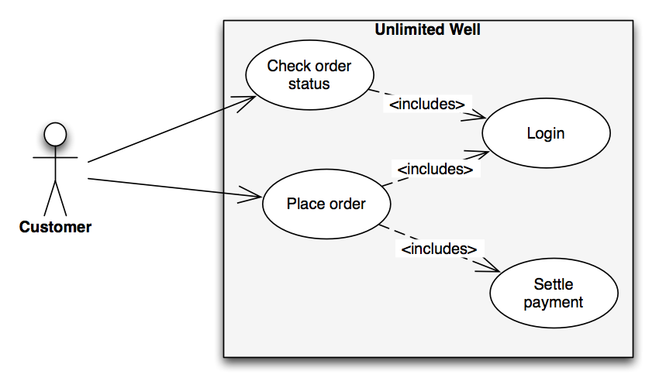

|  |  |
| --- | --- |
| Name | Order goods |
| Goal | Order goods |
| Actor | Customer |
| Preconditions | - |
| Main Flow | 1. Customer search for item(s) 2. Customer finds item(s) 3. Customer selects item(s) 4. Customer places an order 5. Customer receives an e-mail receipt of ordered goods |
| Alternate flow | - |
| Post conditions | Customer holds a receipt of any ordered goods, also describing any back ordered goods |

UC2. Alter registration details 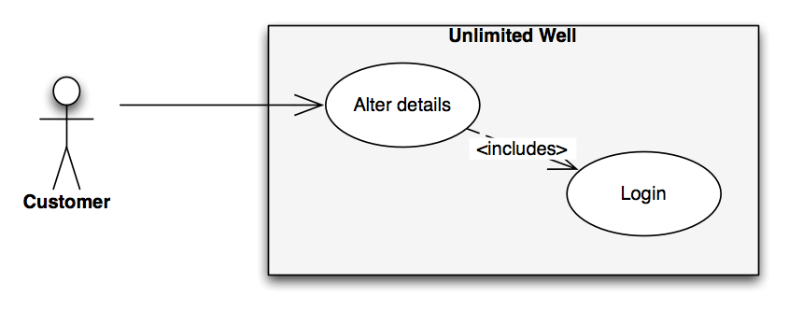

|  |  |
| --- | --- |
| Name | Alter registration details |
| Goal | Alter registration details |
| Actor | Customer |
| Preconditions | Customer is registered |
| Main Flow | 1. Customer logs in to the system 2. Customer clicks "Change registration details 3. Customer makes changes and clics enter 4. The system gives a response message saying wether the change was made or for some reason not possible |
| Alternate flow | - |
| Post conditions | Registration details are changed if posible, otherwise noted |

UC3. Ask about transport for goods 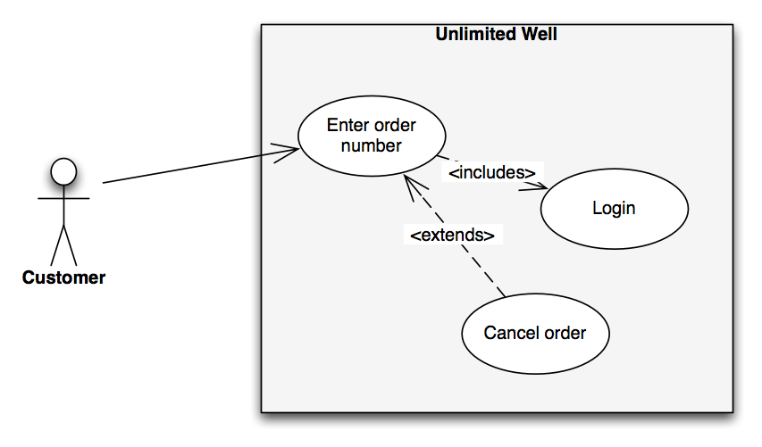

|  |  |
| --- | --- |
| Name | Ask about transport for goods |
| Goal | Get information about transport for goods |
| Actor | Customer |
| Preconditions | An order of the goods has been placed |
| Main Flow | 1. Customer enters order number 2. System finds order and shows available transport data |
| Alternate flow | - |
| Post conditions | The customer has been given all facts about the transport of the goods asked for |

UC4. Update transport status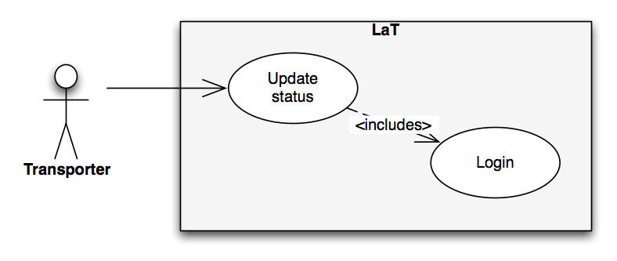

|  |  |
| --- | --- |
| Name | Update transport status |
| Goal | Update transport status |
| Actor | Transporter |
| Preconditions | An order has been placed |
| Main Flow | 1. Transporter logs in to LUW from the view called LaT 2. Transporter updates the transport status |
| Alternate flow | - |
| Post conditions | - |